SUPPORTING INFORMATION FOR:

McClay, P., Ezzeddine, M., Saoji, V. & Jordaan, S. M. (2026). Predicting Electronic Component Mass for Life Cycle Assessment Using Natural Language Processing: Closing Life Cycle Inventory Data Gaps Without Manual Feature Engineering. Journal of Industrial Ecology.
This supporting information provides the material moved from the main text: five supplementary figures (the predictive pipeline, the t-SNE projection of the embedding space, the comparison of text representations and regressors, the predicted-versus-reported and residual plots of the selected model, and the histogram of prediction residuals), eight supplementary tables (reported values for the seven validation products, the mass-cutoff sensitivity analysis, training-data statistics by category, silhouette scores, error metrics by mass range and by component category, and the summary of results across five impact categories), and the definitions and formulae of the performance metrics.

Supplementary Information SI1 (file 1 of 2). The data underlying the figures and tables in this file are provided in Supplementary Information SI2 (Excel workbook); the worksheet holding each dataset is named in the corresponding legend.
Contents
Figure 1. Predictive pipeline implemented in this study
Figure 2. Two-dimensional t-SNE projection of the combined SBERT and character-level TF-IDF feature space
Figure 3. Held-out test-set R² for each combination of text representation and regressor
Figure 4. Predicted versus reported unit mass and residuals of the selected model in the final cross-validation fold
Figure 5. Histogram of prediction residuals in the final cross-validation fold
Table 1. Key reported values for the seven anonymized Schneider Electric products
Table 2. Mean component mass per category across the seven sampled products
Table 3. Model performance and distributional statistics across upper mass percentile cutoffs
Table 4. Training-data metadata by component category after cutoff-based filtering
Table 5. Silhouette analysis of the embedding space by component category
Table 6. Mass-range-based error analysis of the selected model
Table 7. Category-based error analysis of the selected model
Table 8. Summary of the error analysis for five environmental impact categories
Performance Metric Definitions (equations 1–4)
References

Supplementary Figures

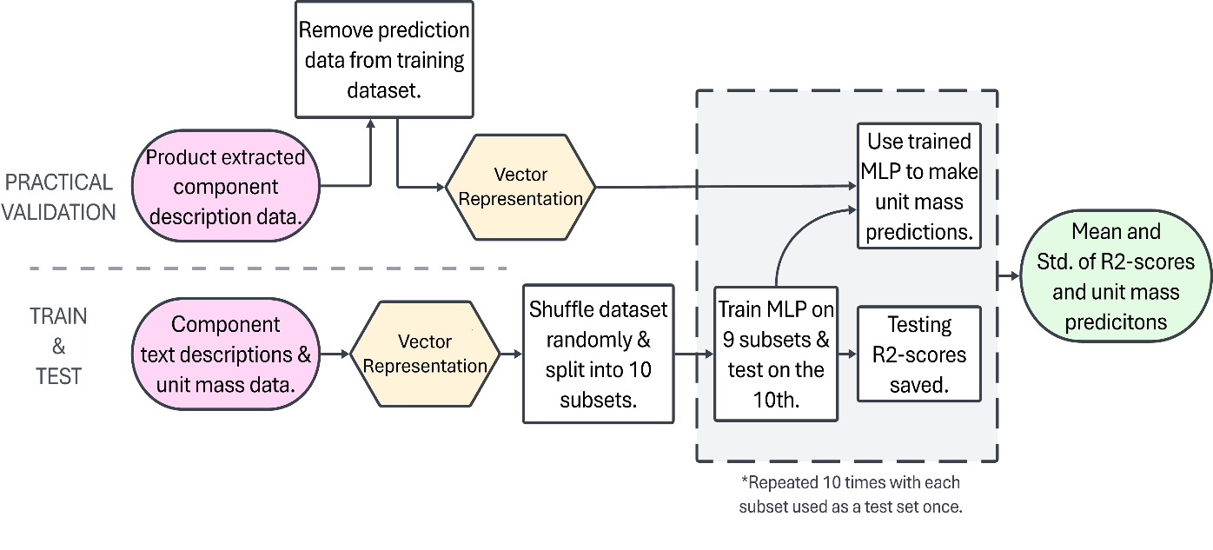
Fig. 1 Predictive pipeline implemented in this study, from raw BoM text input through SBERT embedding, MLP regression, and then use for downstream GWP propagation assessment. Color coding is used to help identify inputs (pink), outputs (green), embedding steps (yellow) and the CV steps (gray) from the other key framework actions (white).

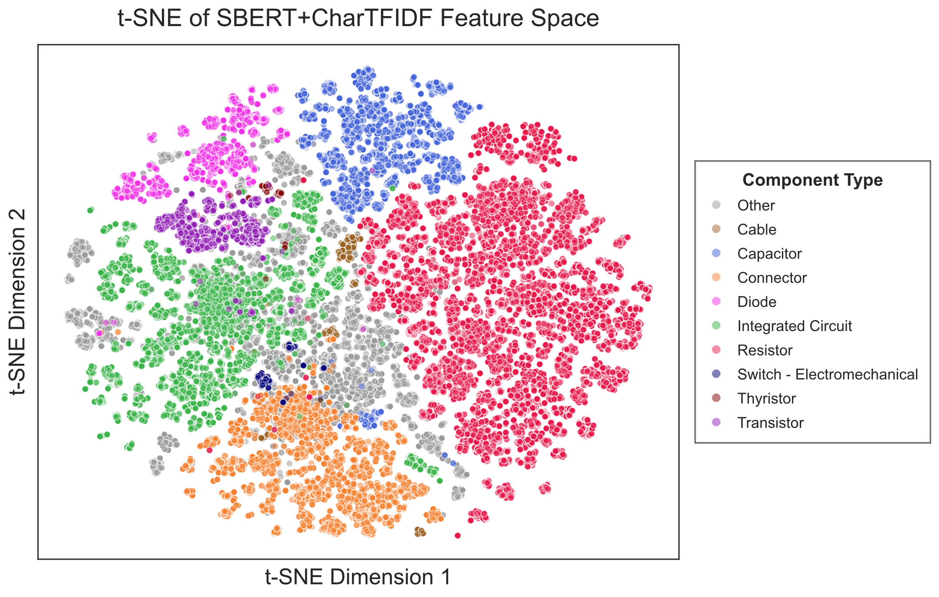
Fig. 2 Two-dimensional t-SNE projection of the combined SBERT and character-level TF-IDF feature space, with points colored by component category. Components of the same family form largely contiguous clusters while more heterogeneous categories overlap. The data underlying Figure 2 can be regenerated from the raw training data in Supplementary Information SI2, sheet 'Raw Training Dataset', using the code available at https://github.com/ETAPA-McGill/NLP-based-LCI-component-mass-prediction; the per-category silhouette scores are provided in Supplementary Information SI2, sheet 'Embedding Space Analysis'.

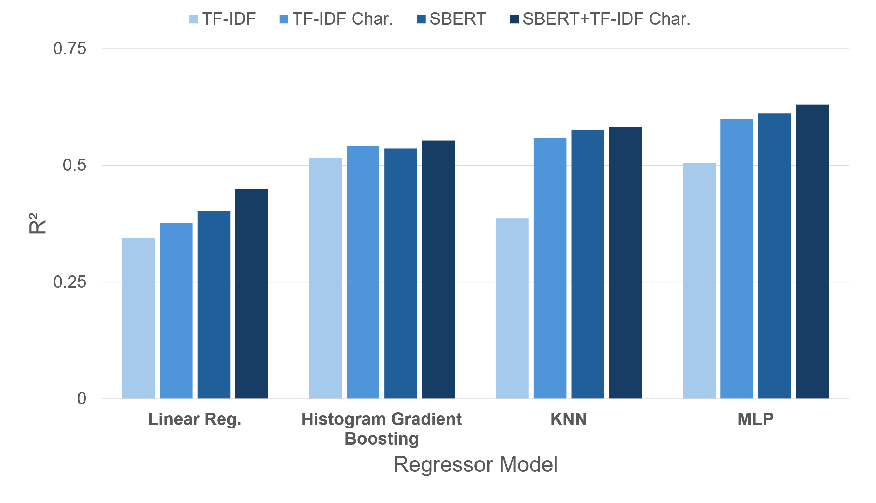
Fig. 3 Held-out test-set R² for each combination of text representation and regressor. Across representations the MLP regressor performed best, and concatenating SBERT with character-level TF-IDF gave the strongest result for every regressor; this combination was adopted for all subsequent analyses. The data underlying Figure 3 can be regenerated from the raw training data in Supplementary Information SI2, sheet 'Raw Training Dataset', using the code available at https://github.com/ETAPA-McGill/NLP-based-LCI-component-mass-prediction.

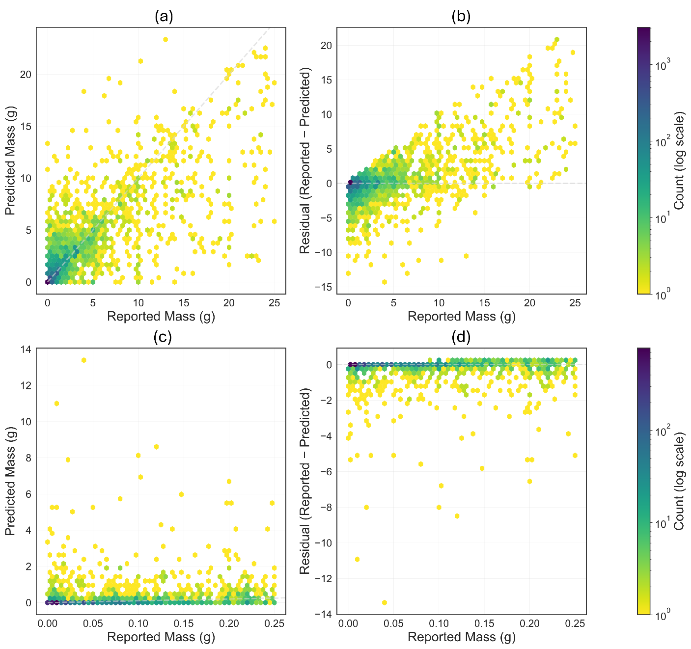
Fig. 4 Overall predictive performance of the selected model using the final cross-validation fold; a) Hexbin plot comparing predicted versus reported unit mass values; color intensity indicates point density; b) Residual plot of prediction error versus reported mass, illustrating increasing variance at higher mass values (heteroscedasticity) and a slight underprediction bias; c) and d) are zoomed in (0-0.25g) version of a) and b), respectively. The data underlying Figure 4 can be regenerated from the raw training data in Supplementary Information SI2, sheet 'Raw Training Dataset', using the code available at https://github.com/ETAPA-McGill/NLP-based-LCI-component-mass-prediction.

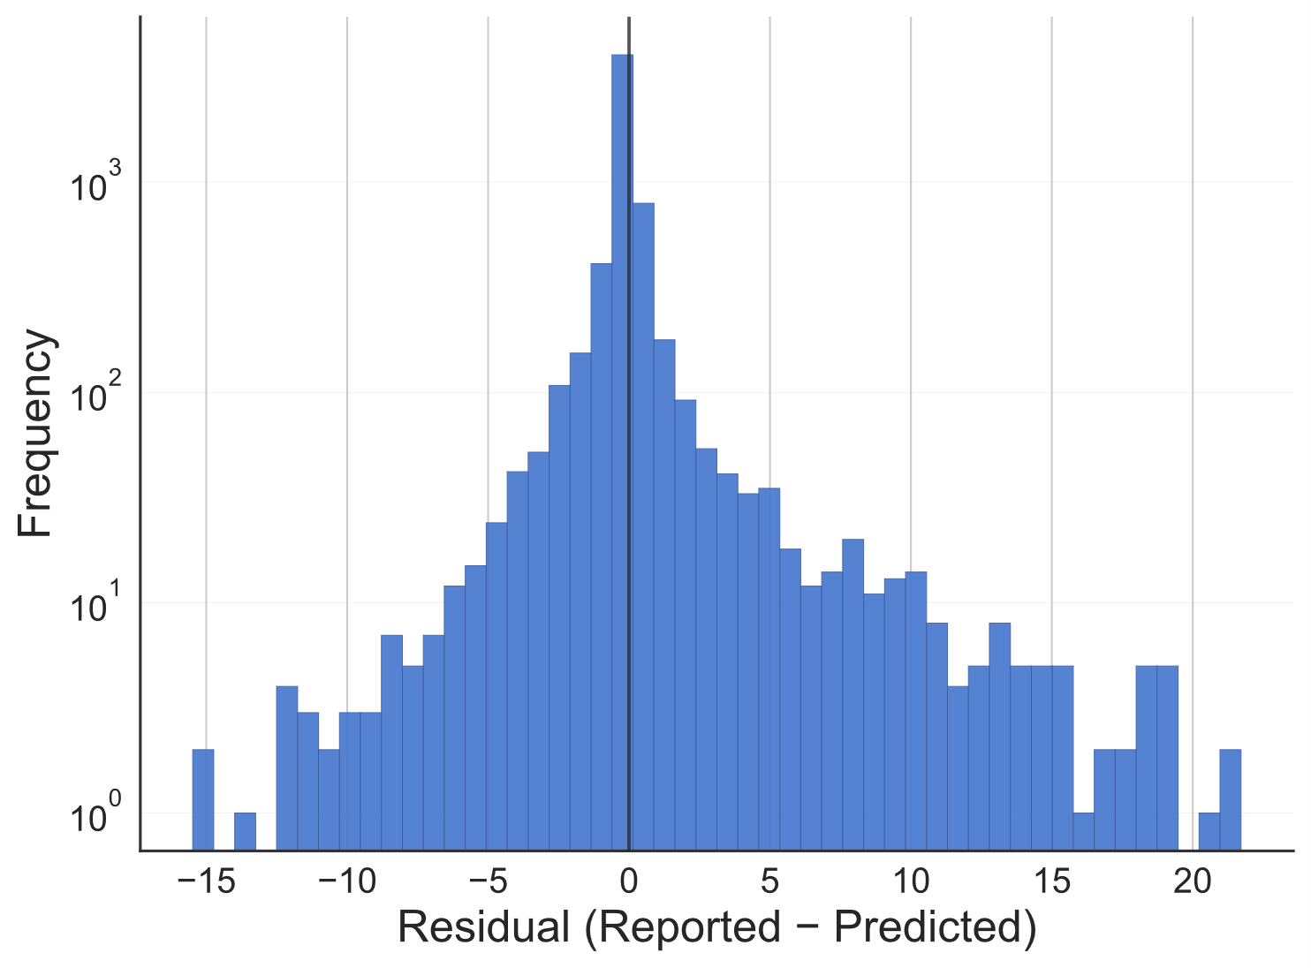
Fig. 5 Histogram of prediction residuals, with a log-scaled frequency axis, across all test samples in the final cross-validation fold, showing a roughly symmetric distribution centered near zero with a slight positive skew. The data underlying Figure 5 can be regenerated from the raw training data in Supplementary Information SI2, sheet 'Raw Training Dataset', using the code available at https://github.com/ETAPA-McGill/NLP-based-LCI-component-mass-prediction.

Supplementary Tables
Table 1: Key reported values for the seven anonymized Schneider Electric products used for downstream validation, including total electronic component (EC) mass, and manufacturing and life cycle GWP. The underlying data can be found in Supplementary Information SI2, sheet 'Data Preprocessing Analysis'.
Product | Reported EC Mass (g) | Reported Life Cycle GWP (kg CO₂e) | Reported Manufacturing Stage GWP (kg CO₂e)
1 | 270.8 | 482.4 | 85.78
2 | 80.55 | 75.84 | 6.486
3 | 68.67 | 158.5 | 31.82
4 | 32.79 | 7.204 | 3.458
5 | 77.03 | 184.1 | 17.24
6 | 61.9 | 9.298 | 6.472
7 | 94.03 | 318.6 | 24.97

Table 2: Mean component mass (g) per category across the seven sampled SE products, with minimum and maximum product-level averages. All category means fall well below the 25 g filtering threshold. The underlying data can be found in Supplementary Information SI2, sheet 'MASS Analysis'.
Component Category | Mean (g) | Min (g) | Max (g)
Capacitors | 0.2104 | 0.01008 | 0.8748
Connectors | 2.417 | 0.1785 | 7.432
Diodes | 0.006619 | 0.00135 | 0.2743
Inductors | 0.3475 | 0.1868 | 1.141
Integrated Circuits | 0.1744 | 0.06881 | 0.2934
Others | 0.6704 | 0.0365 | 4.317
Resistors | 0.004719 | 0.00118 | 0.01263
Transformers | 1.977 | 0.337 | 13
Transistors | 0.1077 | 0.01191 | 0.293
All Components | 0.6639 | 0.00118 | 13
Table 3: Model performance and distributional statistics across upper mass percentile cutoffs. A 25g mass cutoff was adopted as the training threshold (based roughly on the 90th percentile), balancing predictive performance against coverage of the relevant component population. The underlying data can be found in Supplementary Information SI2, sheet 'Data Preprocessing Analysis'.
Percentile | R² | Mean (g) | Median (g) | Max Mass (g) | Skewness | Kurtosis
100 | - | 941 | 0.229 | 49900 | 252 | 65300
99 | 0.567 | 45.8 | 0.22 | 5400 | 10.9 | 142
95 | 0.581 | 5.77 | 0.179 | 173 | 4.98 | 26.5
90 | 0.614 | 1.64 | 0.134 | 28.6 | 3.76 | 15.8
85 | 0.645 | 0.835 | 0.104 | 8.71 | 2.65 | 7.15
80 | 0.688 | 0.521 | 0.0836 | 4 | 2.1 | 3.88

Table 4: Summary of the metadata for each component category in the training data after cutoff-based filtering. The underlying data can be found in Supplementary Information SI2, sheet 'Data Preprocessing Analysis'.
Dataset | N | Mean (g) | Median (g) | Std Dev (g) | Max (g)
Whole Dataset | 62767 | 1.57 | 0.134 | 3.61 | 25
Acoustic Device | 10 | 1.87 | 1.5 | 1.61 | 5
Battery and Accessories | 121 | 6.69 | 5.7 | 5.35 | 24
Cable | 519 | 6.72 | 4 | 7.17 | 25
Capacitor | 6226 | 1.49 | 0.107 | 3.73 | 25
Connector | 7398 | 4.34 | 2.08 | 5.32 | 25
Diode | 3008 | 0.651 | 0.098 | 1.95 | 22
Filter | 15 | 3.08 | 0.488 | 6.33 | 19
Frequency Generation | 603 | 0.487 | 0.137 | 1.39 | 12
Integrated Circuit | 10090 | 0.575 | 0.103 | 1.69 | 24.5
Magnetics | 1615 | 2.29 | 0.58 | 4.22 | 25
Optical | 1232 | 1.21 | 0.145 | 3.51 | 25
Other | 4114 | 2.06 | 0.25 | 4.32 | 25
Protection Device | 2185 | 4.11 | 1.5 | 5.45 | 23.6
Relay | 466 | 10 | 9.91 | 6.25 | 25
Resistor | 22436 | 0.563 | 0.01 | 1.47 | 20.4
Sensor and Accessories | 344 | 2.59 | 0.209 | 5.21 | 24
Switch - Electromechanical | 193 | 2.56 | 0.75 | 4.37 | 25
Thermal Management | 27 | 10.7 | 12.7 | 8.63 | 25
Thyristor | 144 | 1.99 | 1.19 | 3.21 | 20
Transistor | 1995 | 1.46 | 0.198 | 2.87 | 25
Wireless | 26 | 2.12 | 0.175 | 4.73 | 20

Table 5: Silhouette analysis of the embedding space by component category. The underlying data can be found in Supplementary Information SI2, sheet 'Embedding Space Analysis'.
Category | Mean Silhouette
Thyristor | 0.455
Switch - Electromechanical | 0.391
Cable | 0.212
Resistor | 0.198
Transistor | 0.188
Capacitor | 0.142
Diode | 0.124
Connector | 0.106
Integrated Circuit | 0.034
Other | -0.080

Table 6: Mass range based error analysis of the predictive performance of the reported model. The underlying data can be found in Supplementary Information SI2, sheet 'Accuracy Metrics'.
Mass Range (g) | Mean Count (n) | MAE | MAE_std | RMSE | RMSE_std
0.0 - 0.1 | 2900 | 0.104 | 0.00859 | 0.559 | 0.081
0.1 - 0.5 | 1030 | 0.446 | 0.0349 | 1.04 | 0.137
0.5 - 1.0 | 434 | 0.787 | 0.0637 | 1.52 | 0.181
1.0 - 2.0 | 749 | 0.727 | 0.0456 | 1.46 | 0.129
2.0 - 5.0 | 571 | 1.32 | 0.0555 | 2.09 | 0.0773
5.0 - 10.0 | 308 | 2.49 | 0.0669 | 3.28 | 0.118
10.0 - 25.0 | 280 | 6.21 | 0.314 | 8.03 | 0.301

Table 7: Category based error analysis of the predictive performance of the reported model. The underlying data can be found in Supplementary Information SI2, sheet 'Accuracy Metrics'.
Component Category | Mean Count (n) | MAE | MAE_std | RMSE | RMSE_std
Acoustic Device | 1.25 | 1.08 | 0.569 | 1.08 | 0.569
Battery and Accessories | 12.1 | 2.15 | 1.23 | 3.07 | 1.84
Cable | 51.9 | 1.82 | 0.462 | 3.46 | 0.724
Capacitor | 623 | 0.93 | 0.0587 | 2.57 | 0.221
Connector | 740 | 2.19 | 0.127 | 3.8 | 0.247
Diode | 301 | 0.425 | 0.073 | 1.32 | 0.29
Filter | 1.67 | 3.68 | 5.7 | 4.17 | 6.15
Frequency Generation | 60.3 | 0.45 | 0.157 | 1.16 | 0.497
Integrated Circuit | 1010 | 0.436 | 0.0299 | 1.29 | 0.16
Magnetics | 162 | 1.55 | 0.178 | 3.15 | 0.414
Optical | 123 | 0.874 | 0.173 | 2.39 | 0.445
Other | 411 | 1.3 | 0.13 | 2.96 | 0.294
Protection Device | 219 | 1.6 | 0.111 | 2.88 | 0.241
Relay | 46.6 | 3.29 | 0.389 | 4.66 | 0.507
Resistor | 2240 | 0.195 | 0.0154 | 0.866 | 0.111
Sensor and Accessories | 34.4 | 1.59 | 0.286 | 3.1 | 0.701
Switch - Electromechanical | 19.3 | 2.37 | 0.964 | 4.16 | 1.73
Thermal Management | 2.7 | 3.32 | 1.9 | 4 | 2.24
Thyristor | 14.4 | 1.66 | 0.711 | 2.79 | 1.4
Transistor | 200 | 0.511 | 0.0723 | 1.48 | 0.365
Wireless | 2.89 | 2.43 | 2.58 | 3.52 | 3.78

Table 8: Summary of the error analysis for 5 environmental impact categories—Global Warming Potential (GWP), Acidification Potential (AP), Abiotic Depletion Potential of Elements (ADPe) and of Fossil fuels (ADPf), and Water Use (WU)—during the practical validation stage. The underlying data can be found in Supplementary Information SI2, sheet 'Summary of Impact Cat.'.
 | Impact Category | MAE | MAPE | STD | MIN | MAX
Predictions - EC | AP | 0.176 | 27.2 | 0.219 | 0.00854 | 0.662
Predictions - EC | ADPe | 0.00183 | 59 | 0.00241 | 0.0000218 | 0.00634
Predictions - EC | ADPf | 379 | 15.6 | 378 | 25.1 | 1150
Predictions - EC | GWP | 26.9 | 23.7 | 36.6 | 1 | 106
Predictions - EC | WU | 7.31 | 53.9 | 9.79 | 0.0633 | 22.1
Predictions - EC - w/o ICs | AP | 0.063 | 16.1 | 0.057 | 0.00643 | 0.151
Predictions - EC - w/o ICs | ADPe | 0.00019 | 8.73 | 0.000291 | 0.000000945 | 0.000864
Predictions - EC - w/o ICs | ADPf | 166 | 10.2 | 201 | 20.6 | 605
Predictions - EC - w/o ICs | GWP | 7.38 | 13.1 | 6.62 | 0.67 | 13.7
Predictions - EC - w/o ICs | WU | 2.5 | 21.8 | 3.22 | 0.137 | 6.79

Performance Metric Definitions
R² (Coefficient of Determination): Measures the proportion of variance in the target variable explained by the model, using equation 1, where SSR is the residual sum of squares and SST is the total sum of squares (Chicco et al., 2021).
$$R^{2}=1-\frac{SSR}{SST}$$
Values range from negative infinity to 1, with 1 indicating perfect predictive performance and 0 indicating performance equivalent to predicting the mean (Chicco et al., 2021). Negative values indicate performance worse than the mean baseline (Chicco et al., 2021).
(1)
MAE (Mean Absolute Error): The average absolute difference between predicted ($y_{p}$) and reported ($y_{r}$) values, using equation 2 (Chicco et al., 2021).
(2)
$$MAE=\frac{1}{n}\sum_{i}{\left|y_{r}-y_{p}\right|}$$
MAE provides an interpretable measure of typical prediction error in the original units of measurement (e.g. grams), making it easy to understand the practical magnitude of errors (Chicco et al., 2021).
MAPE (Mean Absolute Percentage Error): The average absolute difference between predicted and reported values, relative to the reported value, using equation 3 (Chicco et al., 2021).
(3)
$$MAPE=\frac{1}{n}\sum_{i}{\left|\frac{y_{r}-y_{p}}{y_{r}}\right|}$$
MAPE expresses prediction error as a percentage of the true value, providing a scale-independent measure of accuracy that is particularly useful when comparing errors across components with different mass magnitudes (Chicco et al., 2021).
RMSE (Root Mean Squared Error): The square root of the average squared error, using equation 4 (Chicco et al., 2021).
(4)
$$RMSE=\sqrt{\frac{1}{n}\sum_{i}{{\left(y_{r}-y_{p}\right)}^{2}}}$$
RMSE penalizes larger errors more heavily than MAE and is measured in the same units as the target variable (Chicco et al., 2021). This metric is particularly relevant for identifying whether the model produces occasional large errors that could significantly impact downstream LCA calculations (Chicco et al., 2021).

References
Chicco, D., Warrens, M. J., & Jurman, G. (2021). The coefficient of determination R-squared is more informative than SMAPE, MAE, MAPE, MSE and RMSE in regression analysis evaluation. Peerj computer science, 7, e623. https://peerj.com/articles/cs-623/

